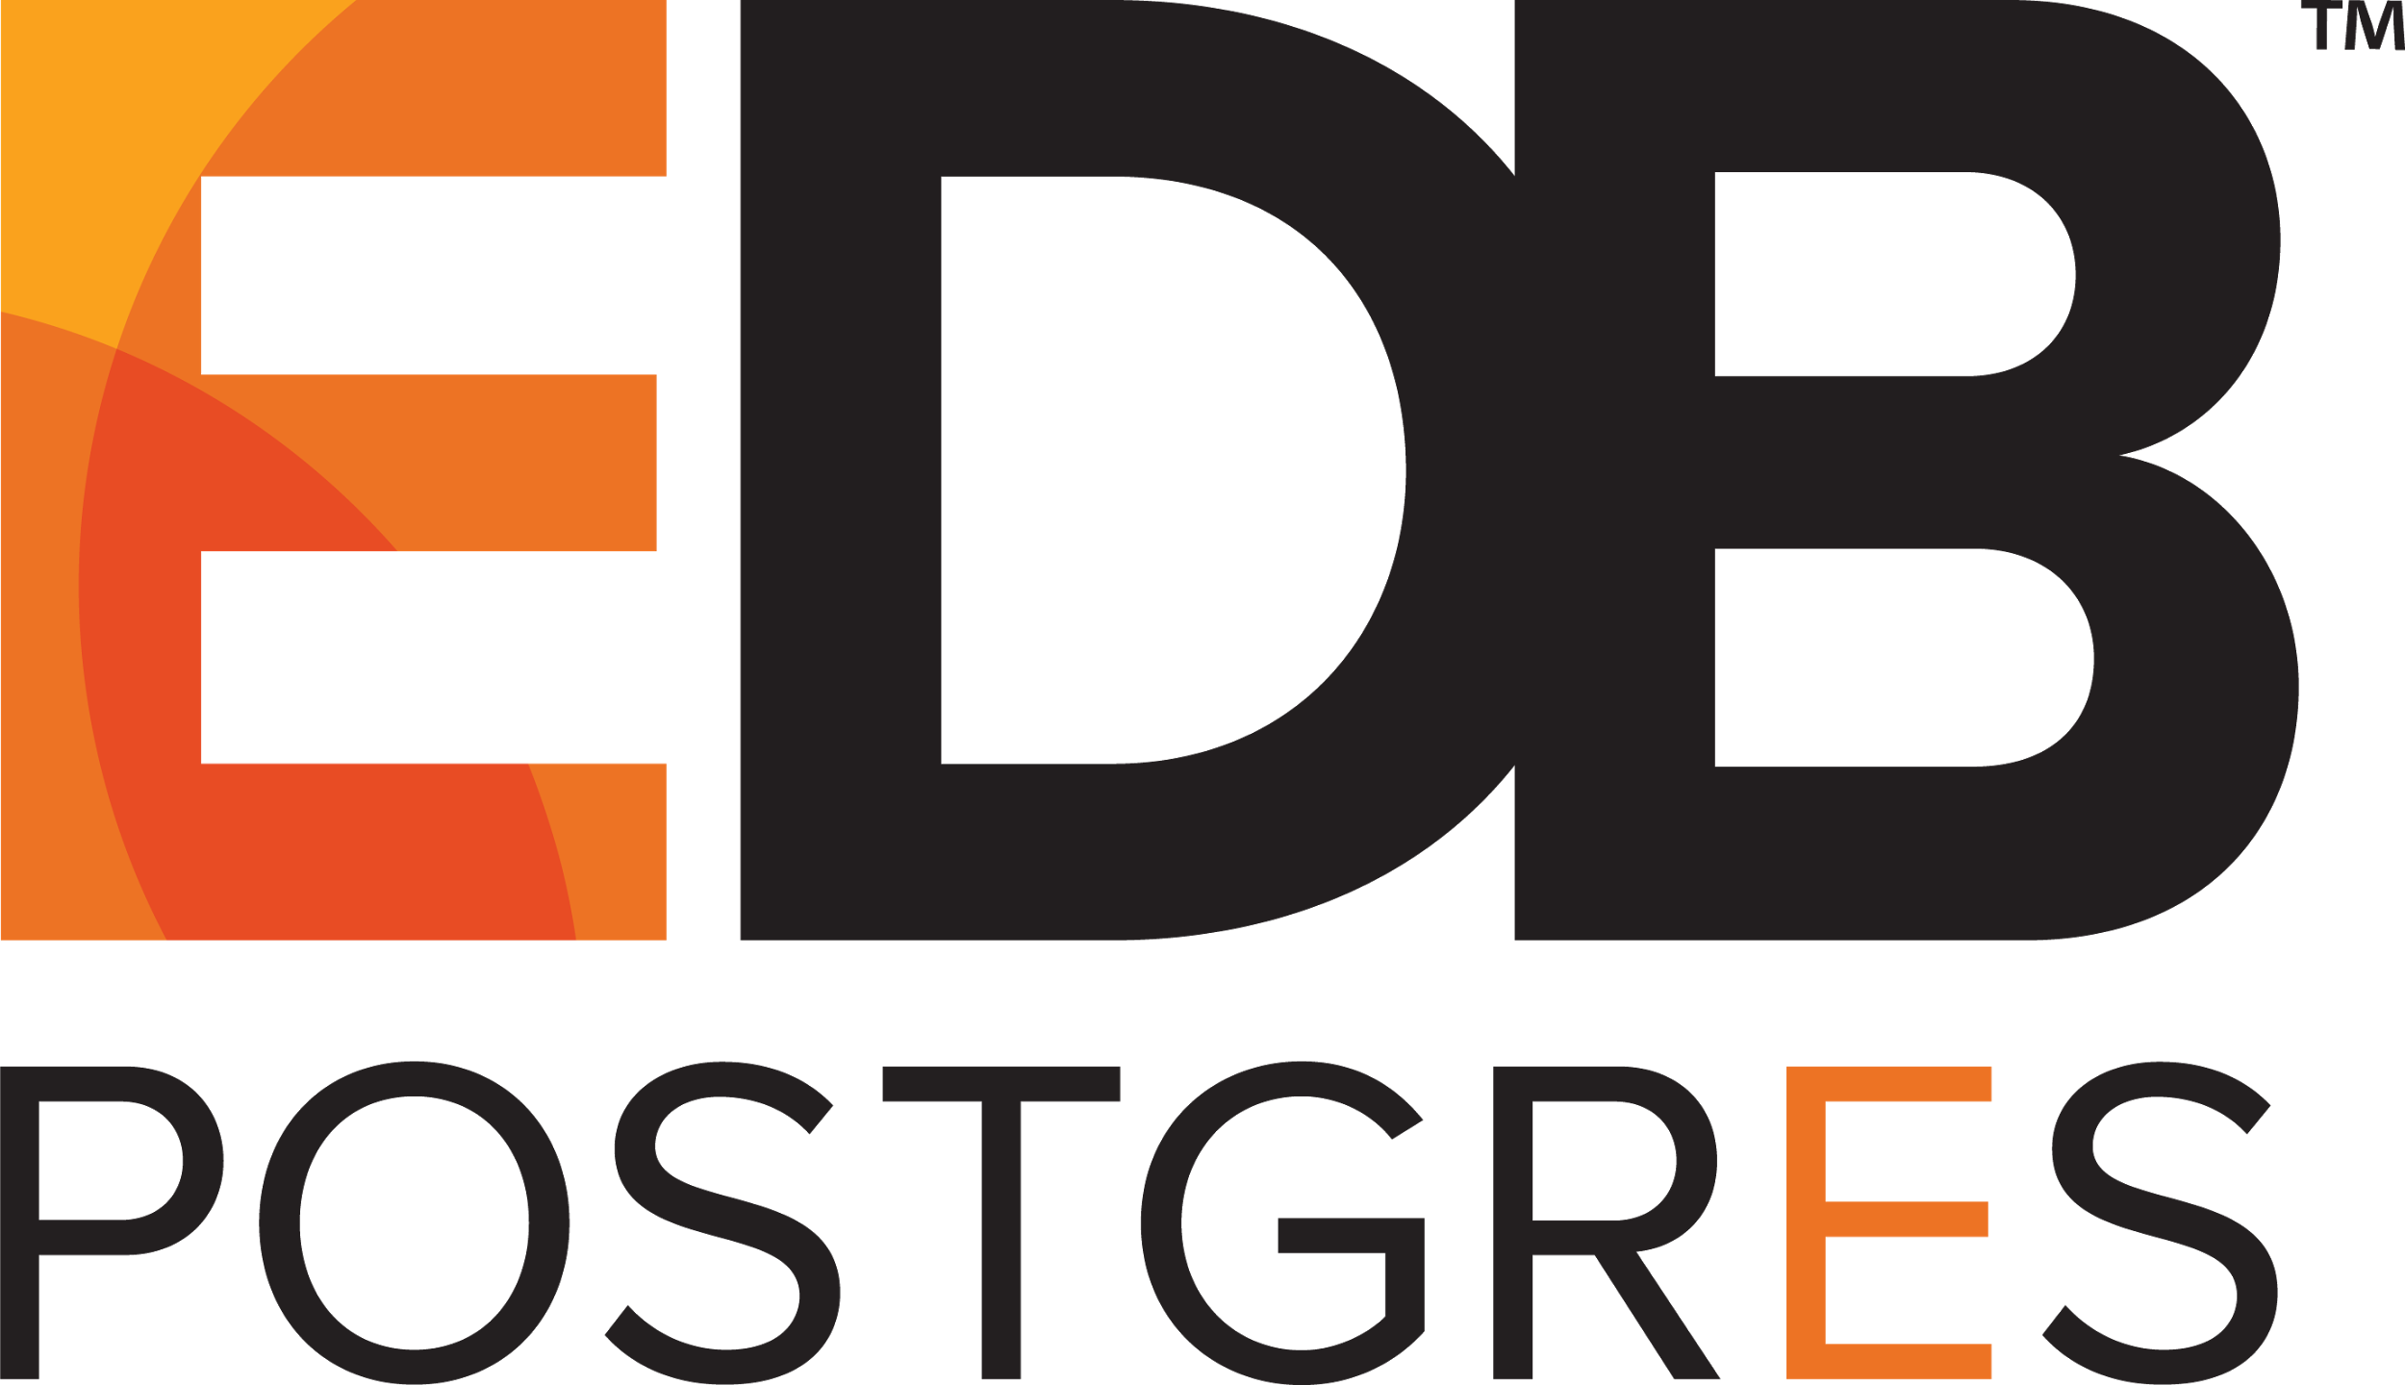

EDB Launches Industry’s First Integrated Open Source-Based Operational Database Management Platform

Enables federated enterprise data management, integrates Postgres with MongoDB and Hadoop, and improves DevOps and Database-as-a-Service with OpenStack and multi-cloud support

BEDFORD, Mass. – May 23, 2016 – EnterpriseDB® (EDB™), the leading enterprise Postgres database company, today announced the immediate availability of the EDB Postgres™ platform, an enterprise class, integrated open source-based database management platform. The EDB Postgres platform enables a wide range of deployment topologies; integrates EDB’s mature, enterprise-ready Postgres database with other leading data management solutions; and offers a specialized partner ecosystem for new, more agile deployment models.

“We are on the cusp of the most significant open source transformation in history, and its economic impact will dwarf the great success of Linux. Companies of all sizes, and particularly the F1000, are systematically unraveling their legacy data management models, infrastructures, and vendors – upgrading each part with open source-based alternatives,” said Ed Boyajian, President and CEO of EDB. “With many proven but discrete open source technologies already widely in use, our customers have been very clear on what they need. They demand a more complete and integrated open source-based solution that meets or beats my current capabilities and at the same time simplifies usage and deployment. This was the imperative that led us to create the EDB Postgres Platform.”

IT organizations face a complex set of decisions regarding their database management infrastructures, and Chief Data and Information Officers struggle to keep pace. With the EDB Postgres platform, organizations have a partner to provide the solutions and support to transform the datacenter into an innovation platform with open source. Many have already begun this transformation with 20 percent of the Fortune 500 having deployed EDB Postgres to transform and modernize operations. They have realized savings of up to 80 percent by deploying EDB Postgres in place of traditional, commercial, and proprietary solutions – savings that could be reinvested in new strategic initiatives for competitive advantage.

“EDB Postgres has brought new levels of efficiency and productivity to our data environment so that IT can emphasize new initiatives and contribute to corporate business objectives,” said Javier Martinez, IT Transformation and Technology Manager, Telefónica S.A., a broadband and telecommunications provider based in Spain. “Working with EDB to develop new capabilities demonstrated the company’s commitment to helping us build a next-generation data center infrastructure that will ensure we can continue to innovate.” According to Gartner, by 2018, more than 70% of new in-house applications will be developed on an OSDBMS, and 50% of existing commercial RDBMS instances either will have been converted or will be in the process of being converted.

“IT organizations across the globe are struggling to meet the demands of the digital transformation, yet the complex and expensive data infrastructures that serve their established back-office applications lack the flexibility and cost-scalability they need for these new application contexts,” said Carl Olofson, Research Vice President, Application Development and Deployment, IDC. “Integrated, subscription-based data management platforms like EDB Postgres enable organizations to move to the third platform, by supporting new agile development models and digital applications, and open source-based data management platforms provide the flexibility for reinvestment in new data-driven initiatives.”

EDB Postgres Partner Ecosystem
EDB has developed a strategic partner ecosystem with leading hardware, software, and service providers to ensure a range of deployment options for end users. EDB also has developed partnerships with Amazon; Google; and Aliyun, the cloud computing division of Alibaba, so that customers have the flexibility to choose an on-premises, cloud or hybrid deployment model. The ability to move workloads seamlessly on and off the cloud, worldwide, as needed, provides enterprises with the flexibility to respond more quickly to shifting demands among internal constituencies.

James Chinn, Chief Executive Officer and Managing Partner at Shadow-Soft, added, “As a Google Cloud Platform services partner, we develop and provide managed services for customers' applications on Google Cloud Platform. With EDB Postgres available via Google Cloud Launcher, we can give our customers quick and easy access to an enterprise-class DBMS with exceptional performance, security, compatibility and affordability.”

Among hardware providers, EDB teams with IBM, HP Enterprise, and Dell, working with those companies to certify EDB Postgres for high-performance computing environments as new platforms have been introduced.

Added Terri Virnig, Vice President of Power Software Solutions, IBM, “The availability of the EDB Postgres Platform on IBM’s Power Systems is an important element of our rapidly expanding Linux on Power ecosystem. Built from the ground up to handle big data, Power Systems running EDB Postgres can deliver our clients a strong data-centric solution to advance their enterprise objectives.”

EDB Postgres Platform
EDB Postgres is the first integrated open source-based operational data management platform that brings together all of the components required for managing structured and unstructured data in a federated model. The platform enables integration across different databases but it also supports combining unstructured data from NoSQL solutions with corporate, transactional data in structured, relational systems.

The EDB Postgres platform includes:
- The choice of two EDB Postgres Database server versions: (i) EDB Postgres Standard Server, an open source PostgreSQL database; or (ii) EDB Postgres Advanced Server, an enhanced version of PostgreSQL with extended enterprise-class performance, scalability, and security features and capabilities, customers have multiple options to fit their unique requirements.
- Solutions in the Management Suite that provide key disaster recovery, high availability, monitoring, management, and tuning capabilities.
- A Migration Suite that enables organizations to migrate workloads from other solutions, especially Oracle, using the database compatibility for Oracle that EDB developed.
- An Integration Suite that features a collection of solutions that support replication of data and the integration of EDB Postgres with other solutions such as MongoDB and Hadoop.
- Support and Services to complement the Postgres solution ecosystem provided to EDB customers as 24x7 global support and upgrades are included with EDB Postgres Platform subscriptions and professional services and training are available to help ensure customers achieve ROI.

EDB Postgres Features and Functionality
The EDB Postgres platform ensures faster multi-master replication; provisioning of private clouds on OpenStack; greater performance and integration across distributed systems; and new Data Adapters for integrating EDB Postgres with other data management solutions to create hybrid data platforms. The newest capabilities include:
- EDB Replication Server – New, binary log-based replication removes all overhead from the publication system and offers sub-second latencies between nodes. Built-in High Availability for the replication control schema eliminates a single point of failure in a replication cluster configuration. Sophisticated pattern matching rules make it easier to identify and support tables for publication in bulk. The new EDB Replication Server is available in single- and multi-master.
- Cloud Management – With support for self-service provisioning, auto-elasticity, self-healing, load balancing and more in private cloud environments with Red Hat or Community OpenStack Kilo, organizations can better support DevOps practices. DBAs can provide their internal and external customers Database-as-a-Service, classifying users based on their needs, use cases and business objectives to speed application development, testing and production.
- Hadoop, MongoDB, and MySQL Data Adapters – EDB Postgres includes Data Adapters with robust support for Hadoop, MongoDB & MySQL. Data Adapters capitalize on the Foreign Data Wrapper (FDW) technology in Postgres and enables data from other database solutions to be queried as if it were native Postgres. With Data Adapters, EDB Postgres eliminates data silos by integrating new, NoSQL database technologies as well as applications based on MySQL with a traditional relational DBMS application. The Data Adaptors are on Github. The Hadoop Data Connector is Hortonworks Data Platform (HDP) Certified and carries the HDP Yarn-ready badge.

Pricing, Availability, and Software Downloads
The EDB Postgres platform is available as a subscription, inclusive of all data management solution components, Postgres support, software upgrades, and access to much of EDB’s partner network. EDB Postgres software can be deployed on bare metal; virtually, including container environments; or in a public, private and/or hybrid cloud environments. EDB Postgres is open source-based, standards-based and runs on all major operating systems, including various distributions of Linux and Windows.

EDB Postgres provides organizations flexibility in pricing and is available in three subscriptions: (i) EDB Postgres Enterprise, (ii) EDB Postgres Standard, and (iii) EDB Postgres Developer. The EDB Postgres Enterprise subscription includes the EDB Postgres Advanced Server database and database compatibility with Oracle. EDB Postgres Standard includes the PostgreSQL database. EDB Postgres Developer offers your choice of DBMS and targets developer use. All three subscriptions include comprehensive management, integration, migration tool suites, global support and upgrades, and are deployable across a wide range of on-premise and cloud configurations.

To get started with the EDB Postgres platform, download EDB Postgres Advanced Server here. EDB invites Postgres users to participate in beta testing of new products. To learn more, please click here. For more information, contact sales@enterprisedb.com.

About EnterpriseDB (EDB) Corporation
EDB is the leading worldwide provider of Postgres software and services that enable enterprises to reduce their reliance on costly traditional solutions and slash their database spend by up to 80%. With powerful performance and security enhancements for PostgreSQL, sophisticated management tools for global deployments and database compatibility for Oracle, EDB software supports both mission and non-mission critical enterprise applications. More than 3,500 enterprises, governments, and other organizations worldwide use EDB software, support, training and professional services to integrate open source software into their existing data infrastructures. Based in Bedford, MA, EDB is backed by private investors.

EnterpriseDB is a registered trademark of EnterpriseDB Corporation. EDB and EDB Postgres are trademarks of EnterpriseDB Corporation. All other names are trademarks of their respective owners.

Media Contacts for EDB:
Nancy Scott Cairbre Sugrue
EnterpriseDB Sugrue Communications
+1 781.357.3090 +44 (0)1932 429 779
Nancy.Scott@EnterpriseDB.com Cairbre@Sugruecomms.com

Gartner, The State of Open-Source RDBMSs, 2015, by Feinberg, Donald & Adrian, Merv, published Apr. 21, 2015.

